Configuring

service docker stop
This command is used to stop the Docker daemon process.

Syntax
service docker stop

Options
None

Return Value
A message showing that the Docker process has stopped.

Example
sudo service docker stop

Output
When we run the above command, it will produce the following result −
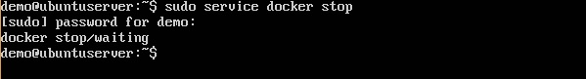

service docker start
This command is used to start the Docker daemon process.

Syntax
service docker start

Options
None

Return Value
A message showing that the Docker process has started.

Example
sudo service docker start

Output
When we run the above command, it will produce the following result −
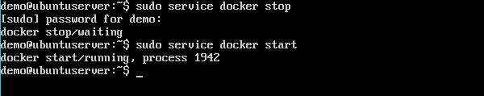

By default, when you launch a container, you will also use a shell command while launching the container as shown below. This is what we have seen in the earlier chapters when we were working with containers.
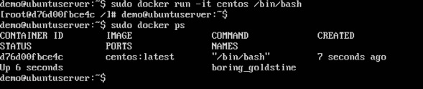
In the above screenshot, you can observe that we have issued the following command −
sudo docker run –it centos /bin/bash
We used this command to create a new container and then used the Ctrl+P+Q command to exit out of the container. It ensures that the container still exists even after we exit from the container.
We can verify that the container still exists with the Docker ps command. If we had to exit out of the container directly, then the container itself would be destroyed.
Now there is an easier way to attach to containers and exit them cleanly without the need of destroying them. One way of achieving this is by using the nsenter command.
Before we run the nsenter command, you need to first install the nsenter image. It can be done by using the following command −
docker run --rm -v /usr/local/bin:/target jpetazzo/nsenter
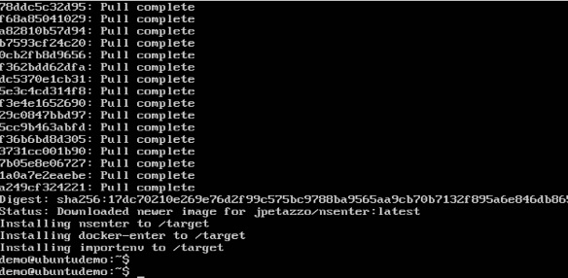
Before we use the nsenter command, we need to get the Process ID of the container, because this is required by the nsenter command. We can get the Process ID via the Docker inspect command and filtering it via the Pid.
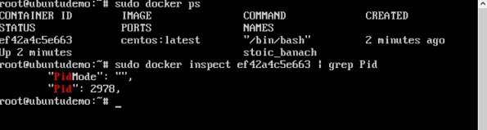
As seen in the above screenshot, we have first used the docker ps command to see the running containers. We can see that there is one running container with the ID of ef42a4c5e663.
We then use the Docker inspect command to inspect the configuration of this container and then use the grep command to just filter the Process ID. And from the output, we can see that the Process ID is 2978.
Now that we have the process ID, we can proceed forward and use the nsenter command to attach to the Docker container.

nsenter
This method allows one to attach to a container without exiting the container.

Syntax
nsenter –m –u –n –p –i –t containerID command

Options
-u is used to mention the Uts namespace
-m is used to mention the mount namespace
-n is used to mention the network namespace
-p is used to mention the process namespace
-i s to make the container run in interactive mode.
-t is used to connect the I/O streams of the container to the host OS.
containerID − This is the ID of the container.
Command − This is the command to run within the container.

Return Value
None

Example
sudo nsenter –m –u –n –p –i –t 2978 /bin/bash

Output
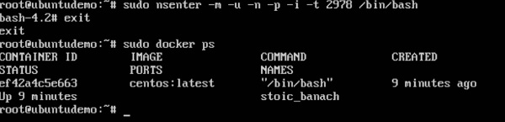
From the output, we can observe the following points −

The prompt changes to the bash shell directly when we issue the nsenter command.
We then issue the exit command. Now normally if you did not use the nsenter command, the container would be destroyed. But you would notice that when we run the nsenter command, the container is still up and running.

In the earlier chapters, we have seen the various Image files such as Centos which get downloaded from Docker hub from which you can spin up containers. An example is again shown below.
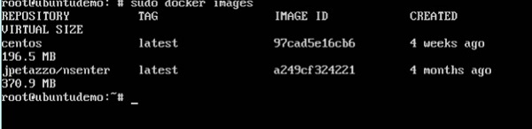

Docker - File
If we use the Docker images command, we can see the existing images in our system. From the above screenshot, we can see that there are two images: centos and nsenter.
But Docker also gives you the capability to create your own Docker images, and it can be done with the help of Docker Files. A Docker File is a simple text file with instructions on how to build your images.
The following steps explain how you should go about creating a Docker File.
Step 1 − Create a file called Docker File and edit it using vim. Please note that the name of the file has to be "Dockerfile" with "D" as capital.
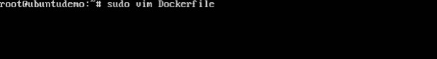
Step 2 − Build your Docker File using the following instructions.
#This is a sample Image
FROM ubuntu
MAINTAINER demousr@gmail.com

RUN apt-get update
RUN apt-get install –y nginx
CMD [“echo”,”Image created”]
The following points need to be noted about the above file −
The first line "#This is a sample Image" is a comment. You can add comments to the Docker File with the help of the # command
The next line has to start with the FROM keyword. It tells docker, from which base image you want to base your image from. In our example, we are creating an image from the ubuntu image.
The next command is the person who is going to maintain this image. Here you specify the MAINTAINER keyword and just mention the email ID.
The RUN command is used to run instructions against the image. In our case, we first update our Ubuntu system and then install the nginx server on our ubuntu image.
The last command is used to display a message to the user.
Step 3 − Save the file. In the next chapter, we will discuss how to build the image.
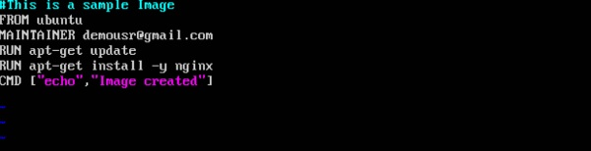

Docker - Building Files
We created our Docker File in the last chapter. It’s now time to build the Docker File. The Docker File can be built with the following command −
docker build
Let’s learn more about this command.

docker build
This method allows the users to build their own Docker images.

Syntax
docker build -t ImageName:TagName dir

Options

-t − is to mention a tag to the image

ImageName − This is the name you want to give to your image.

TagName − This is the tag you want to give to your image.

Dir − The directory where the Docker File is present.

Return Value
None

Example
sudo docker build –t myimage:0.1.
Here, myimage is the name we are giving to the Image and 0.1 is the tag number we are giving to our image.
Since the Docker File is in the present working directory, we used "." at the end of the command to signify the present working directory.

Output
From the output, you will first see that the Ubuntu Image will be downloaded from Docker Hub, because there is no image available locally on the machine.
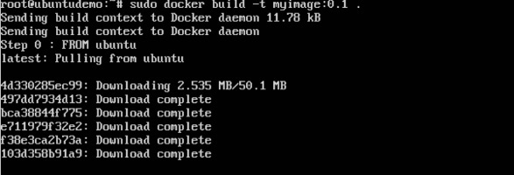
Finally, when the build is complete, all the necessary commands would have run on the image.
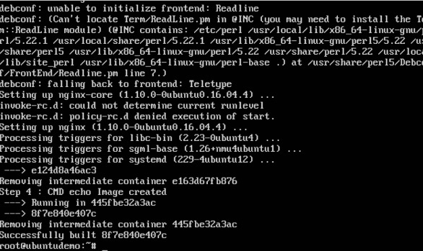
You will then see the successfully built message and the ID of the new Image. When you run the Docker images command, you would then be able to see your new image.
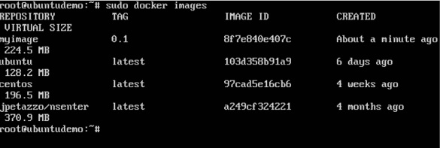
You can now build containers from your new Image.

Docker - Public Repositories
Public repositories can be used to host Docker images which can be used by everyone else. An example is the images which are available in Docker Hub. Most of the images such as Centos, Ubuntu, and Jenkins are all publicly available for all. We can also make our images available by publishing it to the public repository on Docker Hub.
For our example, we will use the myimage repository built in the "Building Docker Files" chapter and upload that image to Docker Hub. Let’s first review the images on our Docker host to see what we can push to the Docker registry.
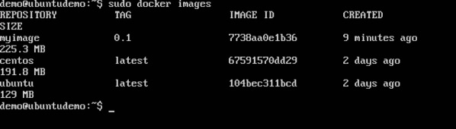
Here, we have our myimage:0.1 image which was created as a part of the “Building Docker Files” chapter. Let’s use this to upload to the Docker public repository.
The following steps explain how you can upload an image to public repository.
Step 1 − Log into Docker Hub and create your repository. This is the repository where your image will be stored. Go to https://hub.docker.com/ and log in with your credentials.
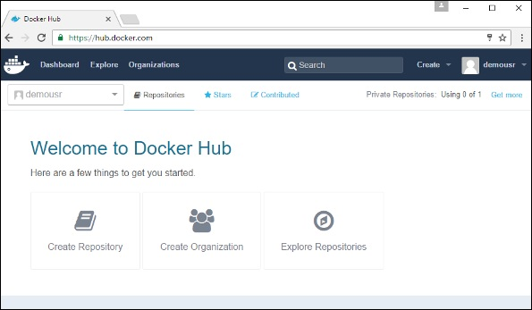
Step 2 − Click the button "Create Repository" on the above screen and create a repository with the name demorep. Make sure that the visibility of the repository is public.
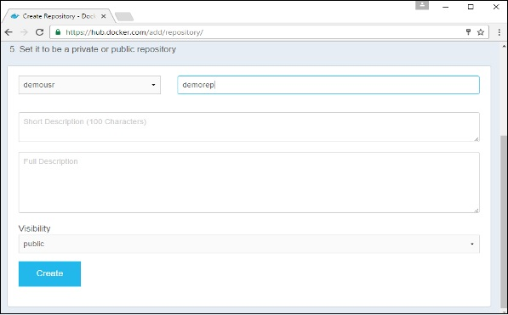
Once the repository is created, make a note of the pull command which is attached to the repository.
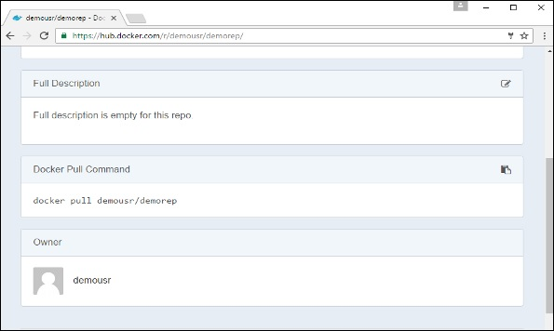
The pull command which will be used in our repository is as follows −
docker pull demousr/demorep
Step 3 − Now go back to the Docker Host. Here we need to tag our myimage to the new repository created in Docker Hub. We can do this via the Docker tag command.
We will learn more about this tag command later in this chapter.
Step 4 − Issue the Docker login command to login into the Docker Hub repository from the command prompt. The Docker login command will prompt you for the username and password to the Docker Hub repository.
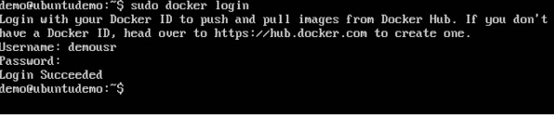
Step 5 − Once the image has been tagged, it’s now time to push the image to the Docker Hub repository. We can do this via the Docker push command. We will learn more about this command later in this chapter.

docker tag
This method allows one to tag an image to the relevant repository.

Syntax
docker tag imageID Repositoryname

Options
imageID − This is the ImageID which needs to be tagged to the repository.
Repositoryname − This is the repository name to which the ImageID needs to be tagged to.

Return Value
None

Example
sudo docker tag ab0c1d3744dd demousr/demorep:1.0

Output
A sample output of the above example is given below.
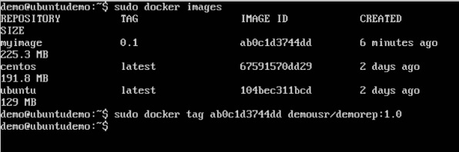

docker push
This method allows one to push images to the Docker Hub.

Syntax
docker push Repositoryname

Options
Repositoryname − This is the repository name which needs to be pushed to the Docker Hub.

Return Value
The long ID of the repository pushed to Docker Hub.

Example
sudo docker push demousr/demorep:1.0

Output
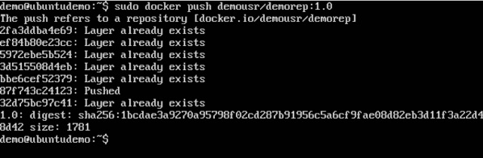
If you go back to the Docker Hub page and go to your repository, you will see the tag name in the repository.
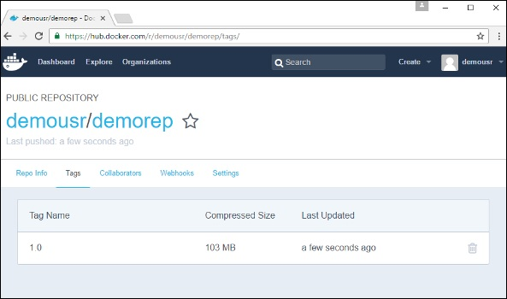
Now let’s try to pull the repository we uploaded onto our Docker host. Let’s first delete the images, myimage:0.1 and demousr/demorep:1.0, from the local Docker host. Let’s use the Docker pull command to pull the repository from the Docker Hub.
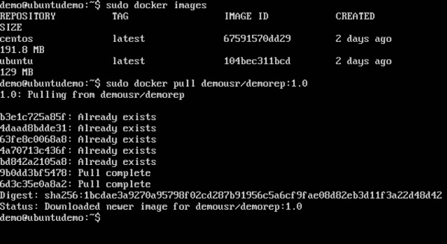
From the above screenshot, you can see that the Docker pull command has taken our new repository from the Docker Hub and placed it on our machine.

Docker - Managing Ports
In Docker, the containers themselves can have applications running on ports. When you run a container, if you want to access the application in the container via a port number, you need to map the port number of the container to the port number of the Docker host. Let’s look at an example of how this can be achieved.
In our example, we are going to download the Jenkins container from Docker Hub. We are then going to map the Jenkins port number to the port number on the Docker host.
Step 1 − First, you need to do a simple sign-up on Docker Hub.
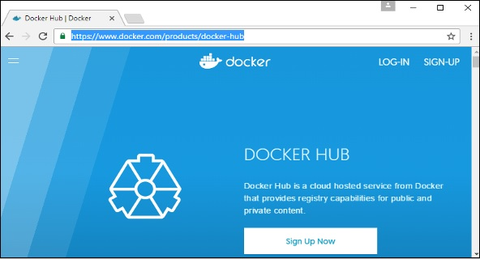
Step 2 − Once you have signed up, you will be logged into Docker Hub.
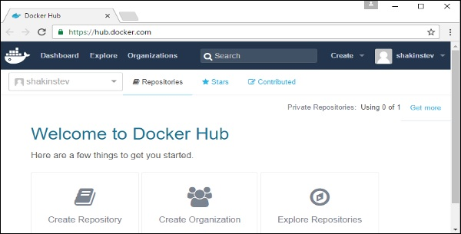
Step 3 − Next, let’s browse and find the Jenkins image.
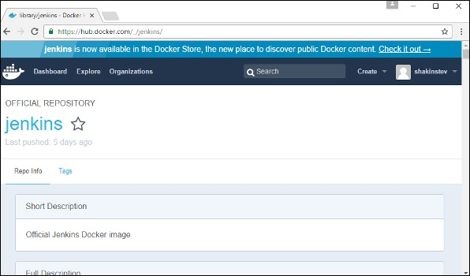
Step 4 − If you scroll down on the same page, you can see the Docker pull command. This will be used to download the Jenkins Image onto the local Ubuntu server.
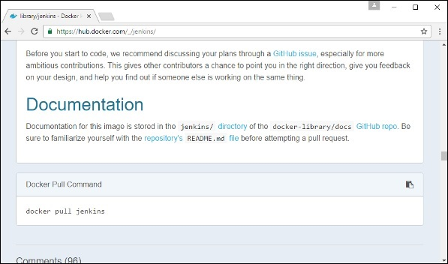
Step 5 − Now go to the Ubuntu server and run the command −
sudo docker pull jenkins
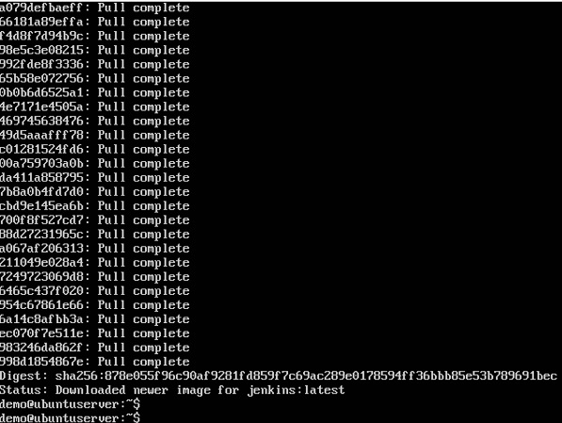
Step 6 − To understand what ports are exposed by the container, you should use the Docker inspect command to inspect the image.
Let’s now learn more about this inspect command.

docker inspect
This method allows one to return low-level information on the container or image.

Syntax
docker inspect Container/Image

Options

Container/Image − The container or image to inspect

Return Value
The low-level information of the image or container in JSON format.

Example
sudo docker inspect jenkins

Output
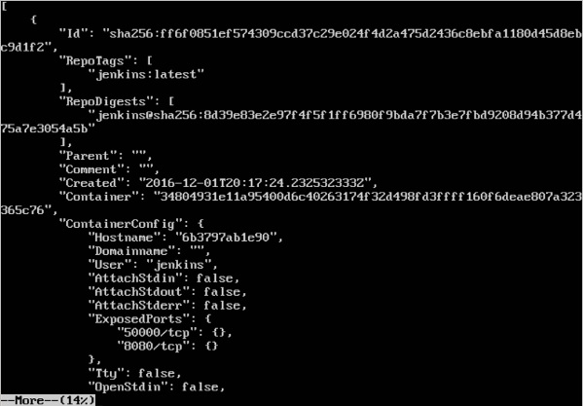
The output of the inspect command gives a JSON output. If we observe the output, we can see that there is a section of "ExposedPorts" and see that there are two ports mentioned. One is the data port of 8080 and the other is the control port of 50000.
To run Jenkins and map the ports, you need to change the Docker run command and add the ‘p’ option which specifies the port mapping. So, you need to run the following command −
sudo docker run -p 8080:8080 -p 50000:50000 jenkins
The left-hand side of the port number mapping is the Docker host port to map to and the right-hand side is the Docker container port number.
When you open the browser and navigate to the Docker host on port 8080, you will see Jenkins up and running.
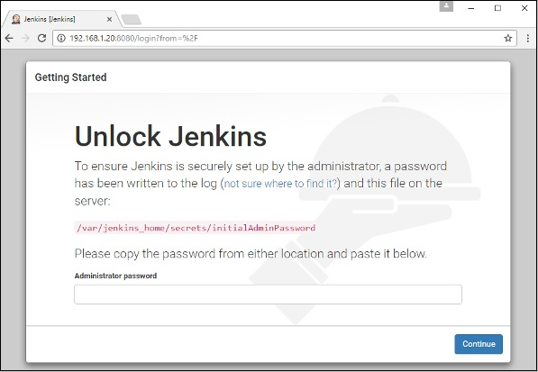

Docker - Private Registries
You might have the need to have your own private repositories. You may not want to host the repositories on Docker Hub. For this, there is a repository container itself from Docker. Let’s see how we can download and use the container for registry.
Step 1 − Use the Docker run command to download the private registry. This can be done using the following command.
sudo docker run –d –p 5000:5000 –-name registry registry:2
The following points need to be noted about the above command −

Registry is the container managed by Docker which can be used to host private repositories.

The port number exposed by the container is 5000. Hence with the –p command, we are mapping the same port number to the 5000 port number on our localhost.

We are just tagging the registry container as “2”, to differentiate it on the Docker host.

The –d option is used to run the container in detached mode. This is so that the container can run in the background

Step 2 − Let’s do a docker ps to see that the registry container is indeed running.
We have now confirmed that the registry container is indeed running.
Step 3 − Now let’s tag one of our existing images so that we can push it to our local repository. In our example, since we have the centos image available locally, we are going to tag it to our private repository and add a tag name of centos.
sudo docker tag 67591570dd29 localhost:5000/centos
The following points need to be noted about the above command −

67591570dd29 refers to the Image ID for the centos image.

localhost:5000 is the location of our private repository.

We are tagging the repository name as centos in our private repository.

Step 4 − Now let’s use the Docker push command to push the repository to our private repository.
sudo docker push localhost:5000/centos
Here, we are pushing the centos image to the private repository hosted at localhost:5000.
Step 5 − Now let’s delete the local images we have for centos using the docker rmi commands. We can then download the required centos image from our private repository.
sudo docker rmi centos:latest
sudo docker rmi 67591570dd29
Step 6 − Now that we don’t have any centos images on our local machine, we can now use the following Docker pull command to pull the centos image from our private repository.
sudo docker pull localhost:5000/centos
Here, we are pulling the centos image to the private repository hosted at localhost:5000.
If you now see the images on your system, you will see the centos image as well.

Docker - Building a Web Server Docker File
We have already learnt how to use Docker File to build our own custom images. Now let’s see how we can build a web server image which can be used to build containers.
In our example, we are going to use the Apache Web Server on Ubuntu to build our image. Let’s follow the steps given below, to build our web server Docker file.
Step 1 − The first step is to build our Docker File. Let’s use vim and create a Docker File with the following information.
FROM ubuntu
RUN apt-get update
RUN apt-get install –y apache2
RUN apt-get install –y apache2-utils
RUN apt-get clean
EXPOSE 80 CMD [“apache2ctl”, “-D”, “FOREGROUND”]
The following points need to be noted about the above statements −
We are first creating our image to be from the Ubuntu base image.
Next, we are going to use the RUN command to update all the packages on the Ubuntu system.
Next, we use the RUN command to install apache2 on our image.
Next, we use the RUN command to install the necessary utility apache2 packages on our image.
Next, we use the RUN command to clean any unnecessary files from the system.
The EXPOSE command is used to expose port 80 of Apache in the container to the Docker host.
Finally, the CMD command is used to run apache2 in the background.

Now that the file details have been entered, just save the file.
Step 2 − Run the Docker build command to build the Docker file. It can be done using the following command −
sudo docker build –t=”mywebserver” .
We are tagging our image as mywebserver. Once the image is built, you will get a successful message that the file has been built.
Step 3 − Now that the web server file has been built, it’s now time to create a container from the image. We can do this with the Docker run command.
sudo docker run –d –p 80:80 mywebserver
The following points need to be noted about the above command −
The port number exposed by the container is 80. Hence with the –p command, we are mapping the same port number to the 80 port number on our localhost.
The –d option is used to run the container in detached mode. This is so that the container can run in the background.
If you go to port 80 of the Docker host in your web browser, you will now see that Apache is up and running.

Docker - Instruction Commands
Docker has a host of instruction commands. These are commands that are put in the Docker File. Let’s look at the ones which are available.

CMD Instruction
This command is used to execute a command at runtime when the container is executed.

Syntax
CMD command param1

Options
command − This is the command to run when the container is launched
param1 − This is the parameter entered to the command.

Return Value
The command will execute accordingly.

Example
In our example, we will enter a simple Hello World echo in our Docker File and create an image and launch a container from it.
Step 1 − Build the Docker File with the following commands −
FROM ubuntu
MAINTAINER demousr@gmail.com
CMD [“echo” , “hello world”]
Here, the CMD is just used to print hello world.
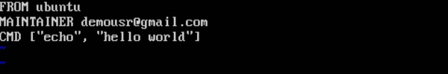
Step 2 − Build the image using the Docker build command.
Step 3 − Run a container from the image.
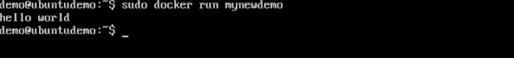

ENTRYPOINT
This command can also be used to execute commands at runtime for the container. But we can be more flexible with the ENTRYPOINT command.

Syntax
ENTRYPOINT command param1

Options
command − This is the command to run when the container is launched.
param1 − This is the parameter entered into the command.

Return Value
The command will execute accordingly.

Example
Let’s take a look at an example to understand more about ENTRYPOINT. In our example, we will enter a simple echo command in our Docker File and create an image and launch a container from it.
Step 1 − Build the Docker File with the following commands −
FROM ubuntu
MAINTAINER demousr@gmail.com
ENTRYPOINT [“echo”]
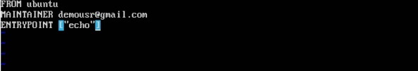
Step 2 − Build the image using the Docker build command.
Step 3 − Run a container from the image.

ENV
This command is used to set environment variables in the container.

Syntax
ENV key value

Options
Key − This is the key for the environment variable.
value − This is the value for the environment variable.

Return Value
The command will execute accordingly.

Example
In our example, we will enter a simple echo command in our Docker File and create an image and launch a container from it.
Step 1 − Build the Docker File with the following commands −
FROM ubuntu
MAINTAINER demousr@gmail.com
ENV var1=Tutorial var2=point
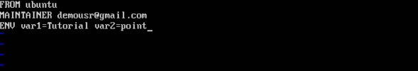
Step 2 − Build the image using the Docker build command.
Step 3 − Run a container from the image.
Step 4 − Finally, execute the env command to see the environment variables.

WORKDIR
This command is used to set the working directory of the container.

Syntax
WORKDIR dirname

Options

dirname − The new working directory. If the directory does not exist, it will be added.

Return Value
The command will execute accordingly.

Example
In our example, we will enter a simple echo command in our Docker File and create an image and launch a container from it.
Step 1 − Build the Docker File with the following commands −
FROM ubuntu
MAINTAINER demousr@gmail.com
WORKDIR /newtemp
CMD pwd
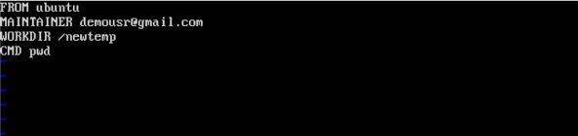
Step 2 − Build the image using the Docker build command.
Step 3 − Run a container from the image.

Docker - Container Linking
Container Linking allows multiple containers to link with each other. It is a better option than exposing ports. Let’s go step by step and learn how it works.
Step 1 − Download the Jenkins image, if it is not already present, using the Jenkins pull command.
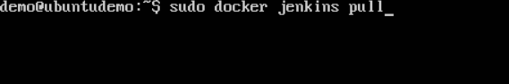
Step 2 − Once the image is available, run the container, but this time, you can specify a name to the container by using the –-name option. This will be our source container.
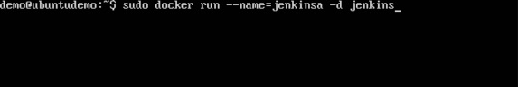
Step 3 − Next, it is time to launch the destination container, but this time, we will link it with our source container. For our destination container, we will use the standard Ubuntu image.
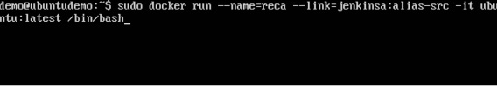
When you do a docker ps, you will see both the containers running.
Step 4 − Now, attach to the receiving container.
Then run the env command. You will notice new variables for linking with the source container.

Docker - Storage

Storage Drivers
Docker has multiple storage drivers that allow one to work with the underlying storage devices. The following table shows the different storage drivers along with the technology used for the storage drivers.
Technology | Storage Driver
OverlayFS | overlay or overlay2
AUFS | aufs
Btrfs | brtfs
Device Manager | devicemanager
VFS | vfs
ZFS | zfs
Let us now discuss some of the instances in which you would use the various storage drivers −

AUFS

This is a stable driver; can be used for production-ready applications.

It has good memory usage and is good for ensuring a smooth Docker experience for containers.

There is a high-write activity associated with this driver which should be considered.

It’s good for systems which are of Platform as a service type work.

Devicemapper

This is a stable driver; ensures a smooth Docker experience.

This driver is good for testing applications in the lab.

This driver is in line with the main Linux kernel functionality.

Btrfs

This driver is in line with the main Linux kernel functionality.

There is a high-write activity associated with this driver which should be considered.

This driver is good for instances where you maintain multiple build pools.

Ovelay

This is a stable driver and it is in line with the main Linux kernel functionality.

It has a good memory usage.

This driver is good for testing applications in the lab.

ZFS

This is a stable driver and it is good for testing applications in the lab.

It’s good for systems which are of Platform-as-a-Service type work.

To see the storage driver being used, issue the docker info command.

Syntax
docker info

Options
None

Return Value
The command will provide all relative information on the Docker component installed on the Docker Host.

Example
sudo docker info

Output
The following output shows that the main driver used is the aufs driver and that the root directory is stored in /var/lib/docker/aufs.
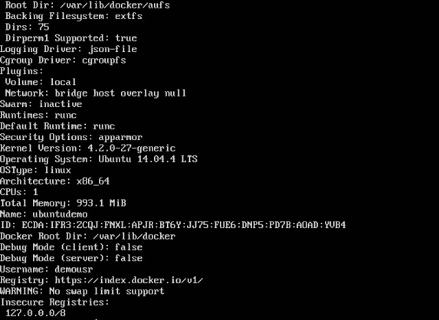

Data Volumes
In Docker, you have a separate volume that can shared across containers. These are known as data volumes. Some of the features of data volume are −
- They are initialized when the container is created.
- They can be shared and also reused amongst many containers.
- Any changes to the volume itself can be made directly.
- They exist even after the container is deleted.
Let’s look at our Jenkins container. Let’s do a docker inspect to see the details of this image. We can issue the following command to write the output of the docker inspect command to a text file and then view the file accordingly.
sudo docker inspect Jenkins > tmp.txt
When you view the text file using the more command, you will see an entry as JENKINS_HOME=/var/Jenkins_home.
This is the mapping that is done within the container via the Jenkins image.
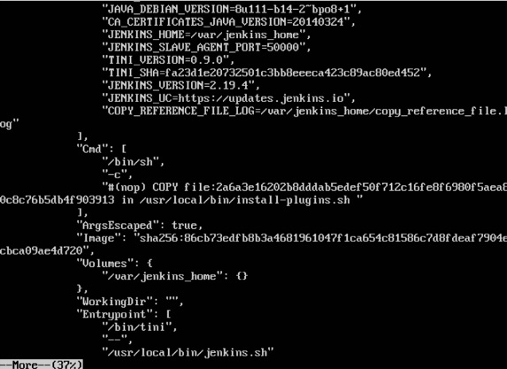
Now suppose you wanted to map the volume in the container to a local volume, then you need to specify the –v option when launching the container. An example is shown below −
sudo docker run –d –v /home/demo:/var/jenkins_home –p 8080:8080 –p 50000:50000 jenkins
The –v option is used to map the volume in the container which is /var/jenkins_home to a location on our Docker Host which is /home/demo.
Now if you go to the /home/demo location on your Docker Host after launching your container, you will see all the container files present there.
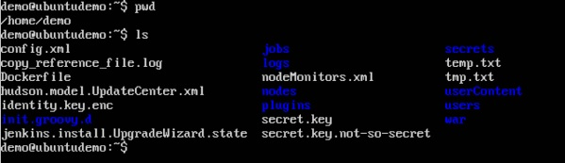

Changing the Storage Driver for a Container
If you wanted to change to the storage driver used for a container, you can do so when launching the container. This can be done by using the –volume-driver parameter when using the docker run command. An example is given below −
sudo docker run –d --volume-driver=flocker
–v /home/demo:/var/jenkins_home –p 8080:8080 –p 50000:50000 jenkins
The –volume-driver option is used to specify another storage driver for the container.
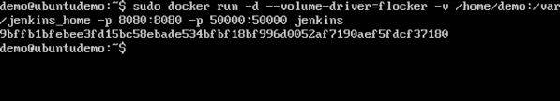
To confirm that the driver has been changed, first let’s use the docker ps command to see the running containers and get the container ID. So, issue the following command first −
sudo docker ps
Then issue a docker inspect against the container and put the output in a text file using the command.
sudo docker inspect 9bffb1bfebee > temp.txt
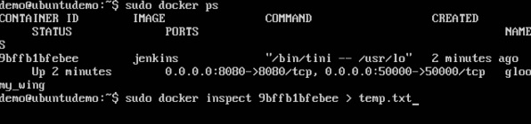
If you browse through the text file and go to the line which says VolumeDriver, you will see that the driver name has been changed.
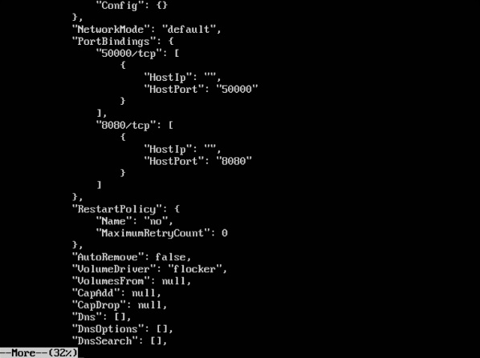

Creating a Volume
A volume can be created beforehand using the docker command. Let’s learn more about this command.

Syntax
docker volume create –-name=volumename –-opt options

Options

name − This is the name of the volume which needs to be created.

opt − These are options you can provide while creating the volume.

Return Value
The command will output the name of the volume created.

Example
sudo docker volume create –-name = demo –opt o = size = 100m
In the above command, we are creating a volume of size 100MB and with a name of demo.

Output
The output of the above command is shown below −
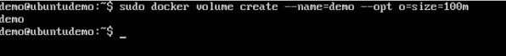

Listing all the Volumes
You can also list all the docker volumes on a docker host. More details on this command is given below −

Syntax
docker volume ls

Options
None

Return Value
The command will output all the volumes on the docker host.

Example
sudo docker volume ls

Output
The output of the above command is shown below −
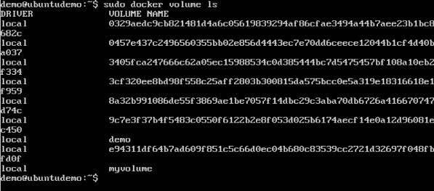

Docker - Networking
Docker takes care of the networking aspects so that the containers can communicate with other containers and also with the Docker Host. If you do an ifconfig on the Docker Host, you will see the Docker Ethernet adapter. This adapter is created when Docker is installed on the Docker Host.
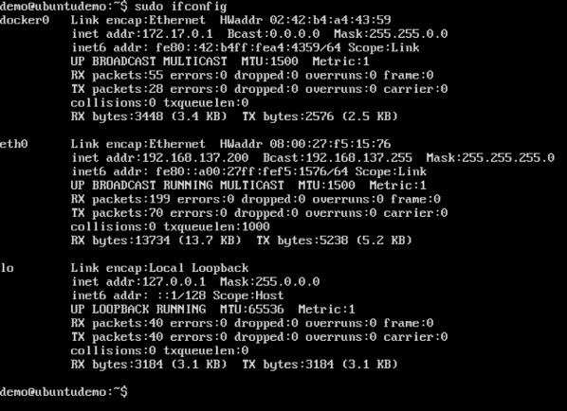
This is a bridge between the Docker Host and the Linux Host. Now let’s look at some commands associated with networking in Docker.

Listing All Docker Networks
This command can be used to list all the networks associated with Docker on the host.

Syntax
docker network ls

Options
None

Return Value
The command will output all the networks on the Docker Host.

Example
sudo docker network ls

Output
The output of the above command is shown below
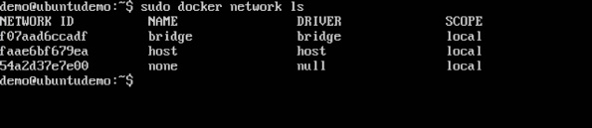

Inspecting a Docker network
If you want to see more details on the network associated with Docker, you can use the Docker network inspect command.

Syntax
docker network inspect networkname

Options

networkname − This is the name of the network you need to inspect.

Return Value
The command will output all the details about the network.

Example
sudo docker network inspect bridge

Output
The output of the above command is shown below −
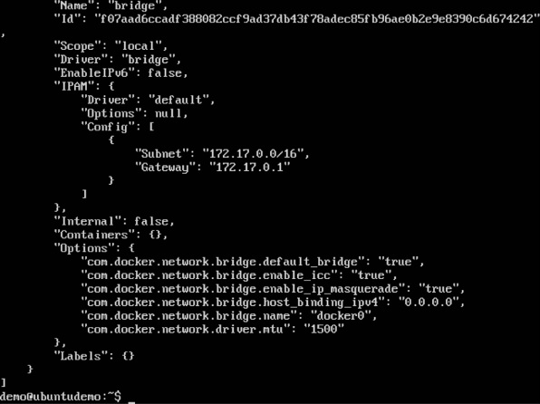
Now let’s run a container and see what happens when we inspect the network again. Let’s spin up an Ubuntu container with the following command −
sudo docker run –it ubuntu:latest /bin/bash
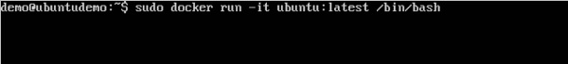
Now if we inspect our network name via the following command, you will now see that the container is attached to the bridge.
sudo docker network inspect bridge
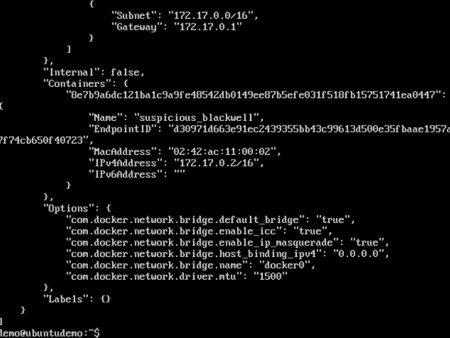

Creating Your Own New Network
One can create a network in Docker before launching containers. This can be done with the following command −

Syntax
docker network create –-driver drivername name

Options

drivername − This is the name used for the network driver.

name − This is the name given to the network.

Return Value
The command will output the long ID for the new network.

Example
sudo docker network create –-driver bridge new_nw

Output
The output of the above command is shown below −
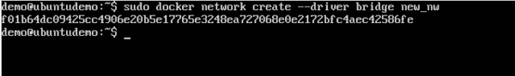
You can now attach the new network when launching the container. So let’s spin up an Ubuntu container with the following command −
sudo docker run –it –network=new_nw ubuntu:latest /bin/bash
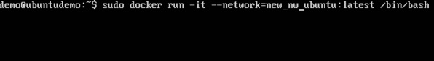
And now when you inspect the network via the following command, you will see the container attached to the network.
sudo docker network inspect new_nw
